# PRACTICAL-1

**AIM:**

Perform the following using Python Pandas and Matplotlib library on given dataset:

1. Deal with missing values in the data either by deleting records or using mean/median/mode imputation.
2. Detect if Outliers exist and plot the data distribution using Box Plots, Scatter Plots and Histograms of matplotlib library

iii) Create and display the correlation matrix of all features of the data. Record and Analyse Observations.

**CODE:**

#IMPORTING LIBRARIES

import pandas as pd

import matplotlib.pyplot as plt

import sklearn

import matplotlib.pyplot as plt

import seaborn as sns

#GETTING THE DATA-SET

df = pd.read_csv('cwurData.csv')

#BOX PLOT USING SEABORN

sns.boxplot(df['broad_impact'])

#SCATTERPLOT USING MATPLOTLIB

fig, plot = plt.subplots(figsize = (15,15))

plot.scatter(df['world_rank'], df['quality_of_education'])

#X-LABEL

plot.set_xlabel('WORLD RANKS')

#Y-LABEL

plot.set_ylabel('QUALITY OF EDUCATION')

plt.show()

plt.boxplot(df['score'])

plt.figure(figsize=(12,5))

#HISTOGRAM USING MATPLOTLIB

plt.hist(df['country'])

plt.xticks(rotation = 90)

plt.show()

#CORRELATION

df.corr()

corrmat = df.corr()

#HEATMAP

sns.heatmap(corrmat,annot=True)

sns.heatmap(corrmat,annot=False)

sns.pairplot(df)

**OUTPUT:**

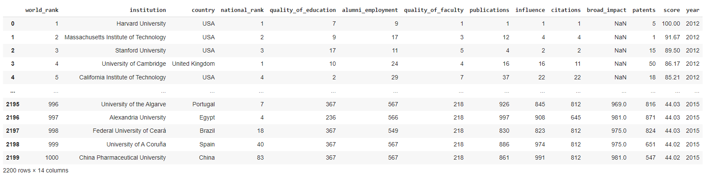

*GLIMPSES OF DATASET*

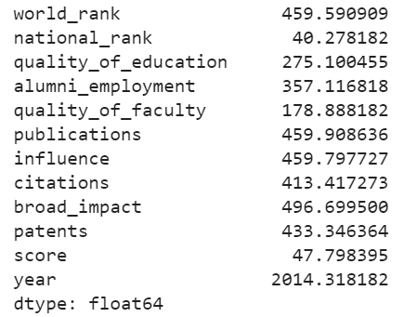 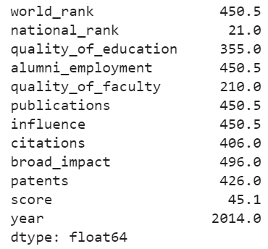

*Mean Median*

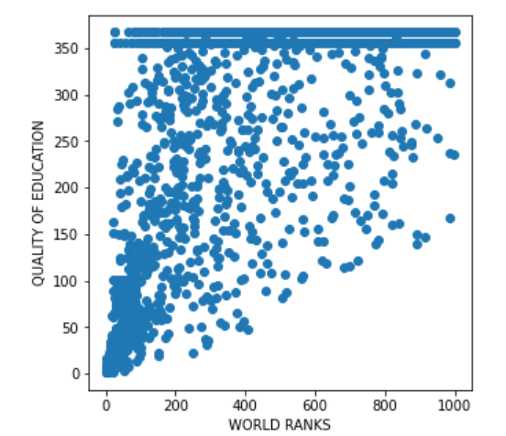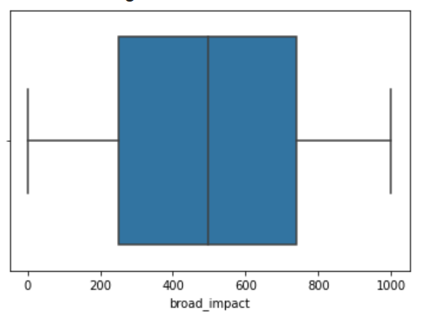

*Scatter plot Boxplot*

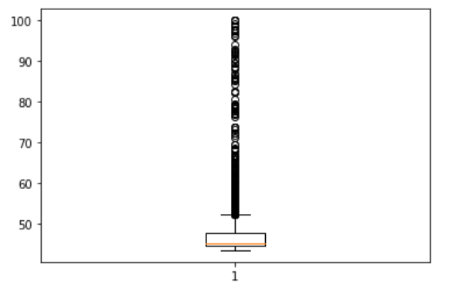

*Boxplot of score column*

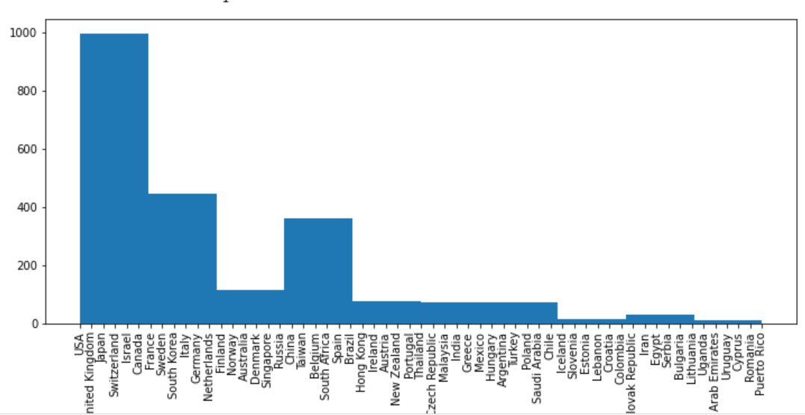

*Histogram*

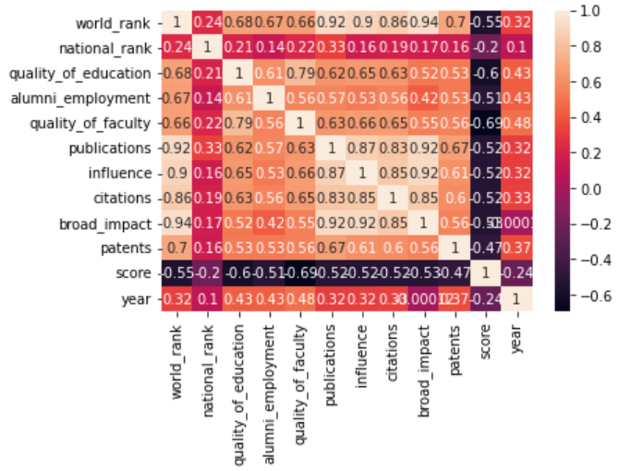

*Correlation heatmap*

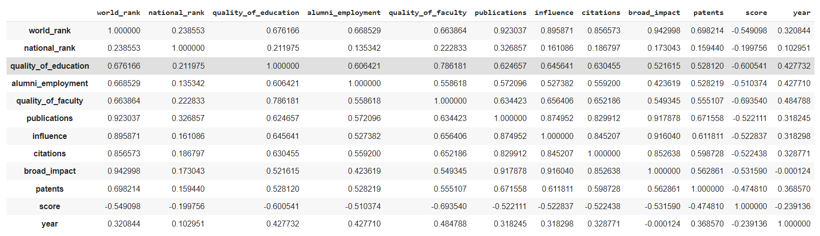

*Correlation matrix*

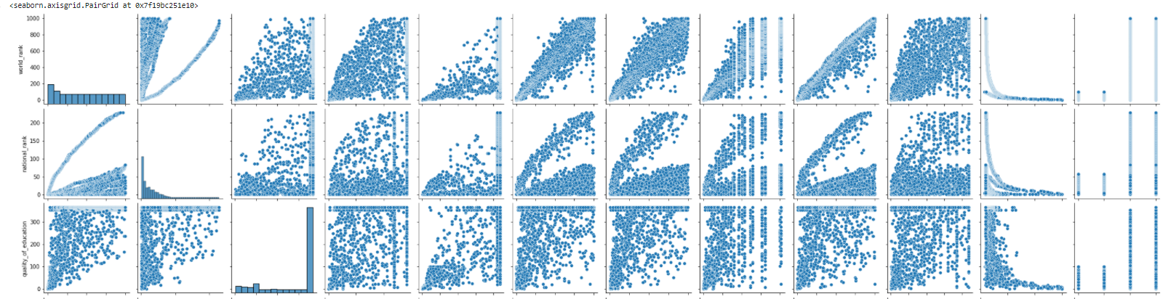

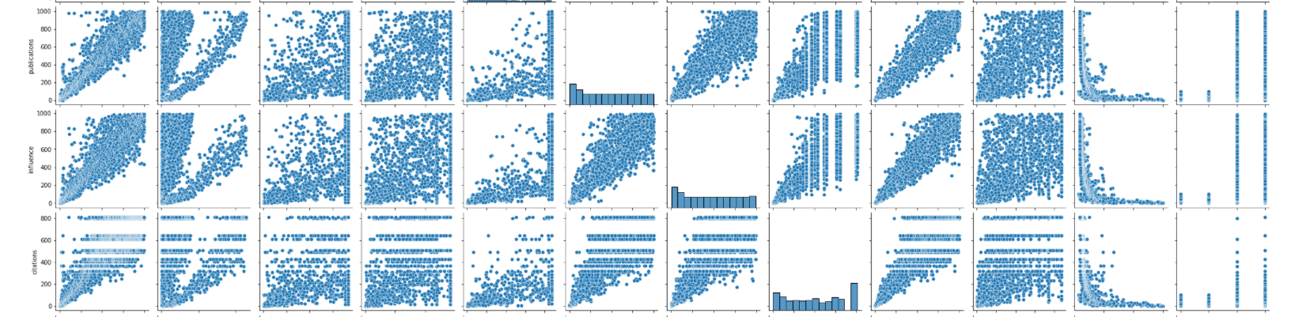

*Pairplot*

# PRACTICAL-2

**AIM:**

For given Dataset (you may continue to use the same processed dataset from experiment 1 only for this experiment), perform the following using Python Pandas and scikit-learn library or by writing your own user-defined function:

1. Perform Data Standardization and Normalization
2. Select the 10 best features of the data using different statistical scoring methods. (Hint: Chi-Squared Statistical Test is a good scoring method)
3. Split the data into training and testing sets in a ratio of 80:20.

**CODE:**

#IMPORTING LIBRARIES

import pandas as pd

import matplotlib.pyplot as plt

from sklearn.preprocessing import StandardScaler

from sklearn.preprocessing import Normalizer

from sklearn.model_selection import train_test_split

from sklearn.feature_selection import SelectKBest

from sklearn.feature_selection import chi2

from sklearn.preprocessing import MinMaxScaler

#GETTING THE DATASET

df = pd.read_csv('winequality-red.csv',sep=';')

y=df['quality']

X = df.drop('quality',inplace=False,axis=1)

# SPLITTING THE DATASET INTO TESTING AND TRAINING SET

X_train,X_test,y_train,y_test= train_test_split(X,y,test_size=0.2,random_state=17)

sc_X = StandardScaler()

sc_X = sc_X.fit_transform(df)

keys = df.head(0).keys()

sc_X = pd.DataFrame(data=sc_X, columns=keys)

sc_X

#STANDARDIZATION

scaler = StandardScaler().fit(X)

standardized_X_train = scaler.transform(X_train)

standardized_X_test = scaler.transform(X_test)

# Normalisation

scalerscaler = Normalizer()

Normalize_x_test = scalerscaler.transform(X_train)

Normalize_y_test = scalerscaler.transform(X_test)

print (Normalize_x_test)

print(df.isna().sum())

scaler = MinMaxScaler()

scaler.fit(df)

scaled_features = scaler.transform(df)

df_MinMax = pd.DataFrame(data=scaled_features,columns=keys)

df_MinMax

bestfeatures = SelectKBest(score_func=chi2,k=3)

fit = bestfeatures.fit(X,y)

dfscores = pd.DataFrame(fit.scores_)

dfcolumns = pd.DataFrame(X.columns)

featureScores = pd.concat([dfcolumns,dfscores],axis=1)

featureScores.columns = ['Column Names','Column Scores']

print(featureScores.nlargest(10,'Column Scores'))

**OUTPUT:**

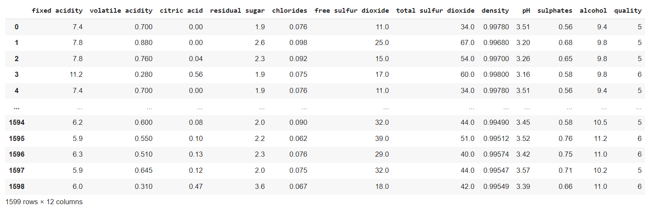

*Glimpses of Dataset*

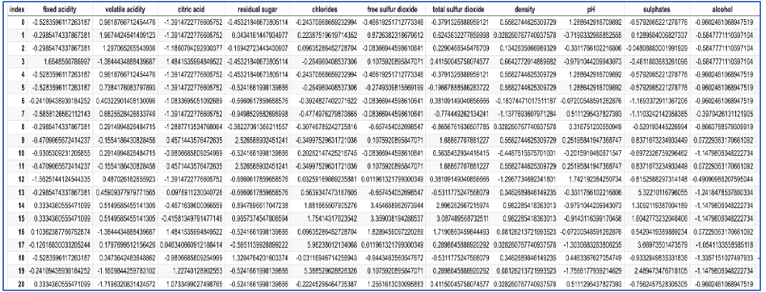

*Data after min max scaler implementation*

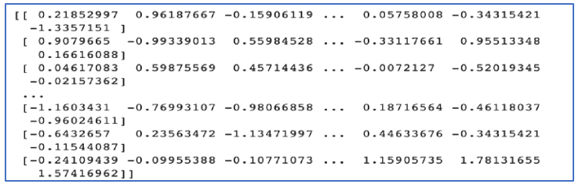

*Standardisation*

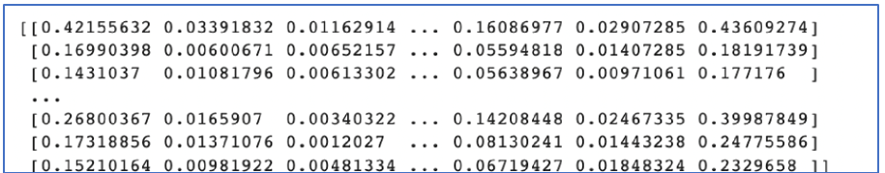

*Normalisation*

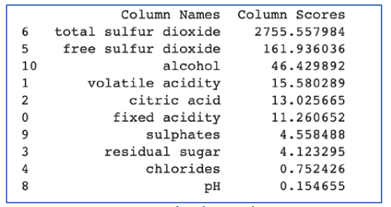

*Best Feature Selection*

# PRACTICAL-3

**AIM:**

Implement the linear regression and calculate the different evaluation measure (MAE, RMSE etc.). for the same. Also implement gradient descent and observe the cost with linear regression using gradient descent. Do not use any Python library for linear regression. (Hint: Linear Regression Formula is Y= mX +b where Y is target

variable and X is independent variable)

**CODE:**

#PRACTICAL-3

import numpy as np

import pandas as pd

import matplotlib.pyplot as plt

#GETTING THE DATASET

df = pd.read_csv('fifa_players.csv')

df.head()

#Removing special character, "M" and "K" for the data column

df['Release Clause'] = df['Release Clause'].str.replace(r"€", "")

df['Release Clause'] = df['Release Clause'].str.replace(r"M", "")

df['Release Clause'] = df['Release Clause'].str.replace(r"K", "")

df['Release Clause'] = df['Release Clause'].astype(float)

x = df.Potential[:1000]

df['Release Clause'] = df['Release Clause'].fillna(0)

y = df['Release Clause'][:1000]

#SCATTER PLOT

plt.scatter(x,y, color='violet')

plt.show()

mean_x = x.mean()  mean_y = y.mean()

tempx = [(i - mean_x)**2 for i in x]

var_x = sum(tempx, 0)/(len(tempx))

tempy = [(i - mean_y)**2 for i in y]

var_y = sum(tempy, 0)/(len(tempy))

#PRINTING VARIANCE

print("Variance of x : ", var_x)

print("Variance of y : ", var_y)

temp1x = [(i - mean_x) for i in x]

temp1y = [(i - mean_y) for i in y]

total = 0

for i in range(len(temp1x)):

  for j in range(len(temp1y)):

    if i == j:

      total = total + temp1x[i]*temp1y[j]

cov = total/(len(temp1x) - 1)

#PRINTING CO-VARIANCE

print("Covariance : ", cov)

r = cov/((var_x*var_y)**0.5)

slope = r*((var_y**0.5)/(var_x**0.5))

c = mean_y - slope * mean_x

print("Value of slope : ", slope)

print("Value of intercept : ", c)

predicted_val = []

for i in range(len(x)):

  new_y = slope*x[i] + c

  predicted_val.append(round(new_y,2))

  print(round(new_y, 2), y[i])

new_meanY = sum(predicted_val)

new_diff = [(i - j)**2 for i, j in zip(y, predicted_val)]

new_sum = sum(new_diff)

mse = new_sum/len(new_diff)

rmse = mse**0.5 print("Mean squared error : ", mse)

print("Root mean squared error : ", rmse)

**OUTPUT:**

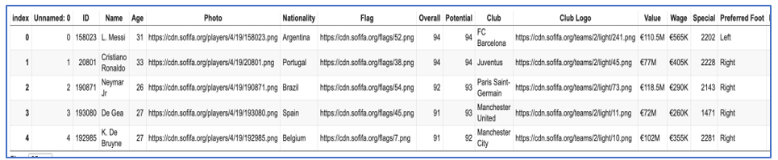

*Glimpses of Dataset*

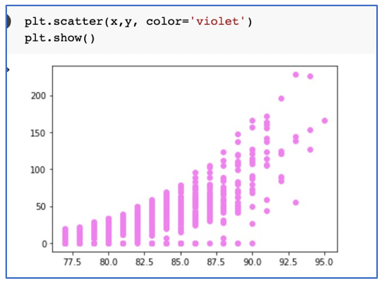

*Scatter plot*



*Variance*



*Slope and Intercept*



*Covariance*



*MSE & RMSE*

**NON-LINEAR REGRESSION:**

**CODE:**

import numpy as np

import pandas as pd

df = pd.read_csv("china_gdp.csv")

df.head()

import matplotlib.pyplot as plt

plt.figure(figsize=(8,5))

x_data, y_data = (df["Year"].values, df["Value"].values)

plt.plot(x_data, y_data, 'ro')

plt.ylabel('GDP')

plt.xlabel('Year')

plt.show()

X = np.arange(-5.0, 5.0, 0.1)

Y = 1.0 / (1.0 + np.exp(-X))

plt.plot(X,Y)

plt.ylabel('Dependent Variable')

plt.xlabel('Indepdendent Variable')

plt.show()

def sigmoid(x, Beta_1, Beta_2):

     y = 1 / (1 + np.exp(-Beta_1*(x-Beta_2)))

     return y

beta_1 = 0.10

beta_2 = 1990.0

#logistic function

Y_pred = sigmoid(x_data, beta_1 , beta_2)

#plot initial prediction against datapoints

plt.plot(x_data, Y_pred*15000000000000.)

plt.plot(x_data, y_data, 'ro')

# Lets normalize our data

xdata =x_data/max(x_data)

ydata =y_data/max(y_data)

from scipy.optimize import curve_fit

popt, pcov = curve_fit(sigmoid, xdata, ydata)

# Now we plot our resulting regression model.

x = np.linspace(1960, 2015, 55)

x = x/max(x)

plt.figure(figsize=(8,5))

y = sigmoid(x, *popt)

plt.plot(xdata, ydata, 'ro', label='data')

plt.plot(x,y, linewidth=3.0, label='fit')

plt.legend(loc='best')

plt.ylabel('GDP')

plt.xlabel('Year')

plt.show()

**OUTPUT:**

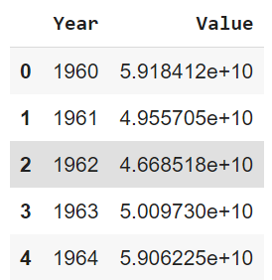

*Glimpses of Dataset*

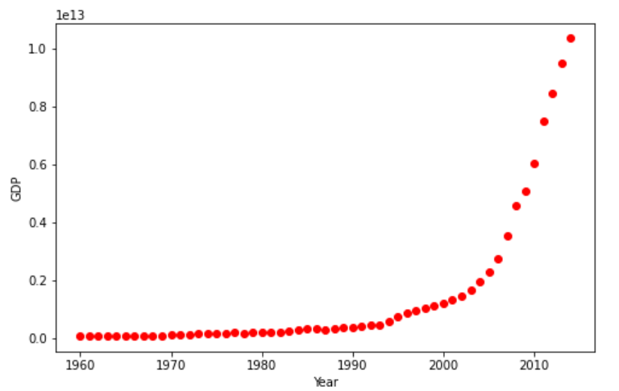 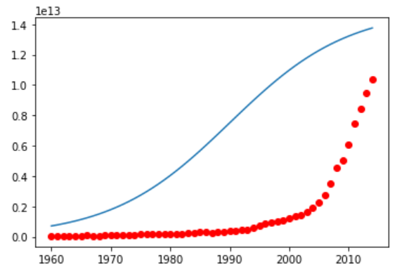

*Plot of Dataset*  *Initial Prediction against data points*

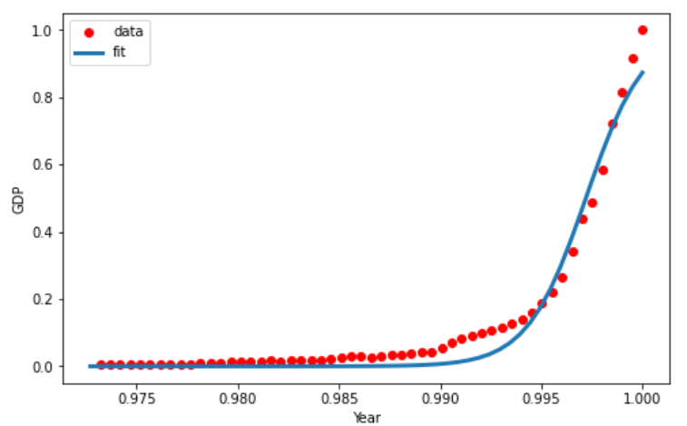

*Graph after normalization*

# PRACTICAL-4

**AIM:**

Create Visual analysis for the given data set using MATLAB.

**BASIC THEORY:**

* The name MATLAB stands for **MATrix LABoratory.**
* It is written in C, C++, and Java.
* Matlab was initially released in 1984.
* MATLAB is a programming platform designed specifically for engineers and scientists to analyze and design systems and products that transform our world.
* Matlab helps to perform mathematical calculation, design, analysis and optimization (structural and mathematical), as well as gives speed, accuracy and precision to results.
* The basic data element of MATLAB as the name suggests is the Matrix or an array.

**Common applications of matlab:**

* Math and computation
* Algorithm development
* Modeling, simulation, and prototyping
* Data analysis, exploration, and visualization
* Scientific and engineering graphics
* Application development, including Graphical User Interface building

**CODE:**

X=[32,53,61,47,59,55,52,39,48,52,45,54,44,58,56,48,44,60,45,38]

Y=[31,68,62,71,87,78,79,59,75,71,55,82,62,75,81,60,82,97,48,56]

n=length(X)

denominator = ( ( n * sum(X .* X)) - sum(X) * sum(X))

b = ( ( sum(Y) * sum(X.*X) ) - ( sum(X) .* sum(X.*Y) ) ) / denominator

m = ( n * sum( X .* Y ) - (sum(X) * sum(Y) ) ) / denominator

yCalc1 = X.*m + b

RGB = [255 0 0]/256

scatter(X,Y,[],RGB)

hold on

plot(X,yCalc1)

xlabel('X')

ylabel('Y')

title('LINEAR REGRESSION')

**OUTPUT:**

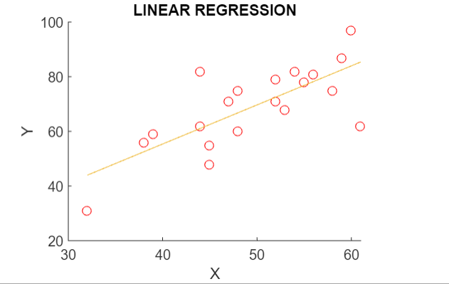

*Linear Regression Output*

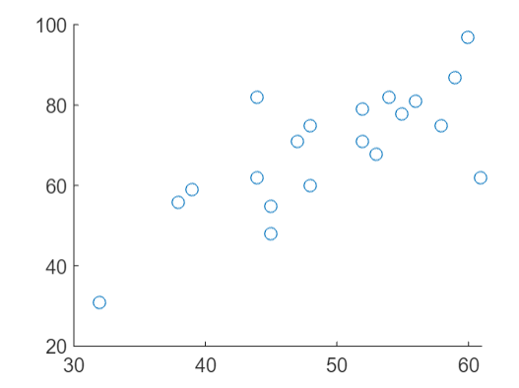 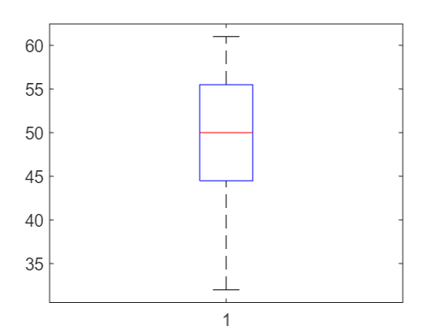

*Scatter Plot Box Plot*

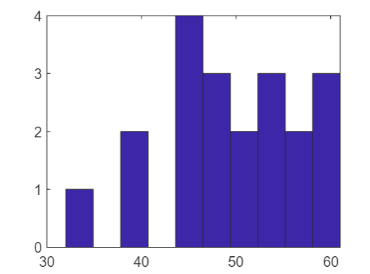 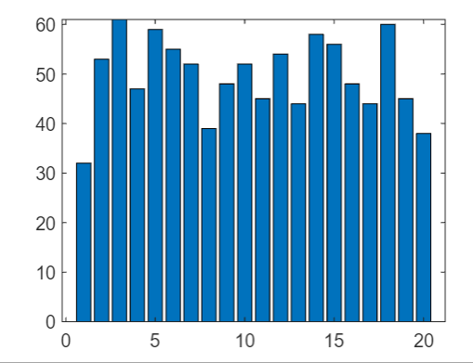

*Histogram Bar plot*

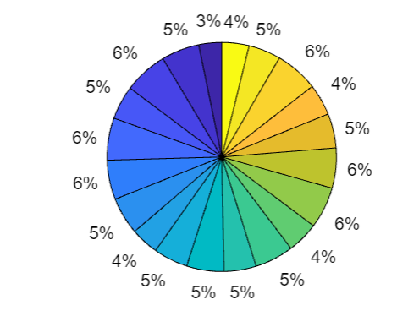

*Pie Chart*

# PRACTICAL-5

**AIM:**

Implement logistic regression and calculate the different evaluation measure (F-measures, Confusion Matrix etc.) for the same. Also implement gradient descent and observe the cost with logistic regression using gradient descent. (Hint: Confusion Matrix and Fmeasures involve use of True Negatives, True Positives, False Negatives and False Positives). Also implement Cross- Validation

**CODE:**

#PRACTICAL-5

import pandas as pd

from sklearn.linear_model import LogisticRegression

from sklearn.preprocessing import Normalizer

from sklearn.preprocessing import StandardScaler

from sklearn.metrics import confusion_matrix, ConfusionMatrixDisplay

from sklearn.metrics import precision_recall_fscore_support

import matplotlib.pyplot as plt

#GETTING DATASET

df = pd.read_excel('default of credit card clients.xls')

df1 = df.rename(columns=df.iloc[0]).drop(df.index[0])

df1

df1.drop('ID',inplace = True, axis = 1)

df1.head(2)

#DEFINING DEPENDENT AND INDEPENDENT VARIABLE

y = df1['default payment next month']

x = df1.drop('default payment next month',inplace =False,axis = 1)

#IMPLEMENTING LOGISTIC REGRESSION CLASSIFIER

y=y.astype('int')

classifier = LogisticRegression().fit(x, y)

classifier.score(x,y)

#IMPLEMENTING NORMALIZATION CLASSIFIER

transformer = Normalizer().fit(x)

x_norm = transformer.transform(x)

x_norm

classifier = LogisticRegression().fit(x_norm,y)

classifier.score(x_norm,y)

scaler = StandardScaler().fit(x)

std_x=scaler.transform(x)

std_x

cls=LogisticRegression().fit(std_x,y)

cls.score(std_x,y)

y_pred=cls.predict(std_x)

y_pred

#BUILDING CONFUSION MATRIX

mat = confusion_matrix(y,y_pred)

print(mat)

conf = ConfusionMatrixDisplay(mat)

conf.plot()

#FINDING OUT PRECISION,RECALL AND F1 SCORE

precision, recall, f1, support = precision_recall_fscore_support(y,y_pred)

**OUTPUT:**

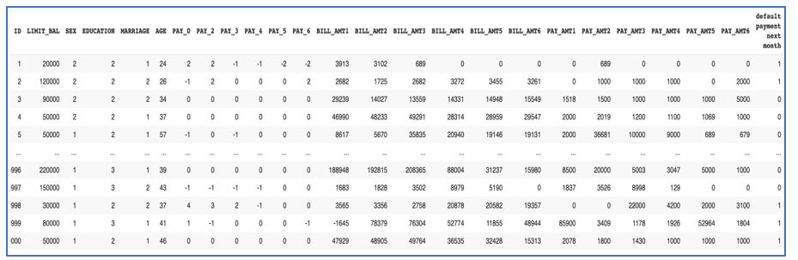

*Glimpses of Dataset*

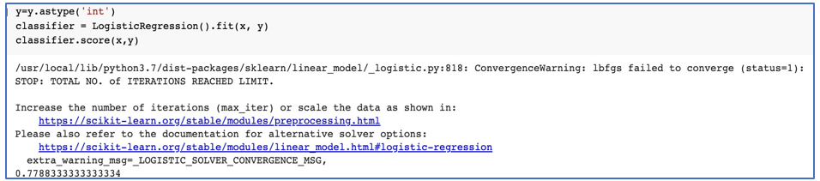

*Logistic Regression*

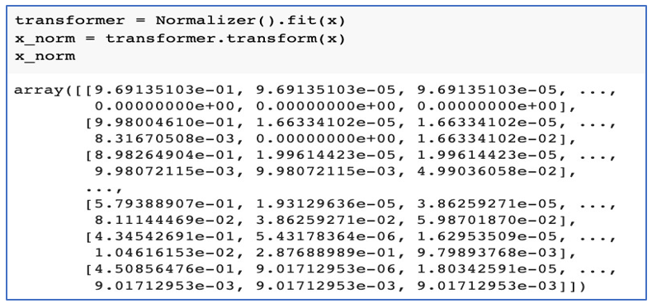

*Normalizer procedure*

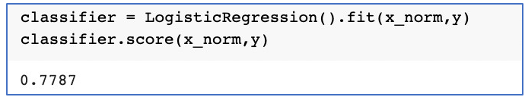

*Logistic Regression*

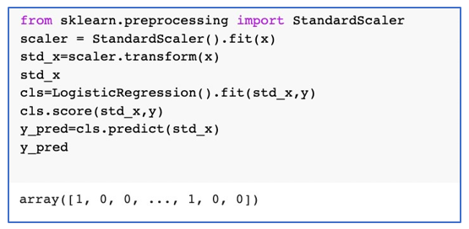 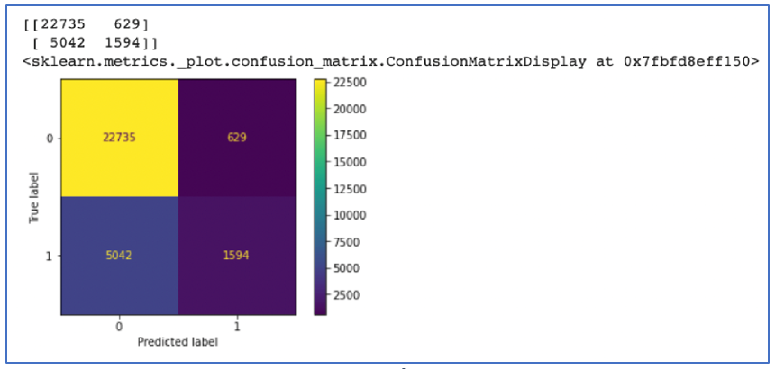

*Standard scaler implementation Confusion Matrix*

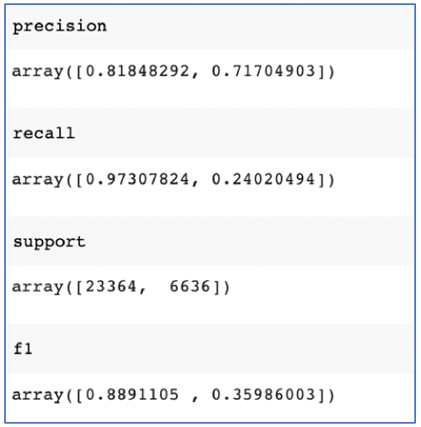

*F1 score, precision, recall*

# PRACTICAL-6

**AIM:**

Implement K-Nearest Neighbours, Support Vector Machine (SVM) and Naïve Bayes Classifier with python’s Scikit-Learn on different datasets. Compare the classifiers based on their evaluation measures.

**CODE:**

#PRACTICAL-6

import pandas as pd

from sklearn.model_selection import train_test_split

from sklearn.neighbors import KNeighborsClassifier

from sklearn.metrics import f1_score

import matplotlib.pyplot as plt

from sklearn.svm import LinearSVC

from sklearn.naive_bayes import GaussianNB

dft = pd.read_excel('default of credit card clients.xls')

df=dft.rename(columns=dft.iloc[0]).drop(dft.index[0])

df.head()

df['default payment next month'].unique()

y = df['default payment next month']

y=y.astype('int')

y.head()

X=df.drop('default payment next month',axis=1,inplace=False)

X.head()

X_train,X_test,y_train,y_test = train_test_split(X,y)

X_train.head()

f1=[]

n_neighbours = [i for i in range(2,20)]

for i in range(2,20):

  neigh = KNeighborsClassifier(n_neighbors=i,algorithm='auto')

  neigh.fit(X_train, y_train)

  y_pred = neigh.predict(X_test)

  f1.append(f1_score(y_test,y_pred,average='weighted'))

  print(f"The fi score when neighbours is {i} is {f1_score(y_test,y_pred,average='weighted')}")

plt.plot(n_neighbours,f1)

svm_clf = LinearSVC()

svm_clf.fit(X_train,y_train)

y_pred = svm_clf.predict(X_test)

svm_clf_f1 = f1_score(y_test,y_pred,average='weighted') print(svm_clf_f1)

gnb = GaussianNB()

gnb.fit(X_train,y_train)

y_pred = gnb.predict(X_test)

gnb_f1 = f1_score(y_test,y_pred,average='weighted')

print(gnb_f1)

**OUTPUT:**

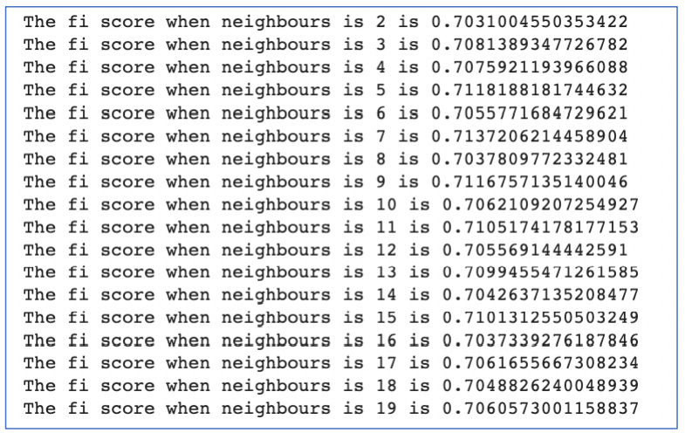 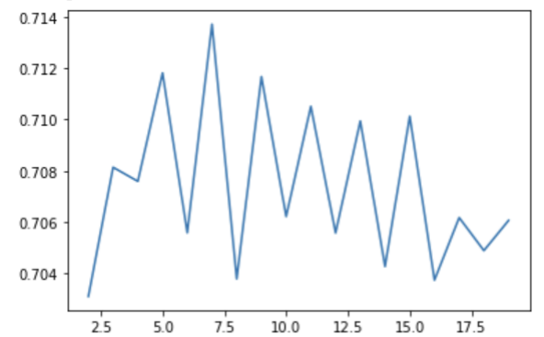

*K nearest neighbour output KNN graph plot*

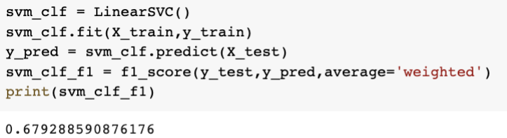

*Linear SVC implementation*

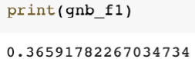

*Gaussian Naïve bayes implementation*

# PRACTICAL-7

**AIM:**

Use K-Means Clustering and Hierarchical Clustering algorithm for following datasets

**CODE:**

#PRACTICAL-7

import pandas as pd

from sklearn.cluster import KMeans

from pandas.core.common import random_state

import matplotlib.pyplot as plt

from sklearn.cluster import AgglomerativeClustering

import numpy as np

from scipy.cluster.hierarchy import dendrogram

df=pd.read_csv('data.csv')

df.head()

df.drop('diagnosis', inplace=True, axis=1)

df.drop('Unnamed: 32', inplace=True, axis=1)

df.drop('id', inplace=True, axis=1)

kmeans = KMeans(n_clusters=2, random_state=0).fit(df)

kmeans.cluster_centers_

kmeans.predict([[1.93799237e+01, 2.16945802e+01, 1.28231298e+02, 1.18592977e+03,

 1.01294580e-01, 1.48612977e-01, 1.76939466e-01, 1.00698779e-01,

 1.91539695e-01, 6.06029008e-02, 7.42803817e-01, 1.22253817e+00,

 5.25058015e+00, 9.56781679e+01, 6.59868702e-03, 3.21766947e-02,

 4.24197710e-02, 1.56739847e-02, 2.03039695e-02, 3.95338931e-03,

 2.37094656e+01, 2.89126718e+01, 1.58496183e+02, 1.75302290e+03,

 1.40424733e-01, 3.57757710e-01, 4.49306107e-01, 1.92431069e-01,

 3.11881679e-01, 8.61654962e-02]])

WCSS=[]

for i in range(2,11):

 kmeans= KMeans(n_clusters=i, random_state=42, init='k-means++').fit(df)

 WCSS.append(kmeans.inertia_);

WCSS

no_of_cluster = [i for i in range(2,11)]

plt.plot(no_of_cluster, WCSS)

clustering = AgglomerativeClustering(distance_threshold=0, n_clusters=None).fit(df)

clustering.labels_

def plot_dendrogram(model, **kwargs):

 counts = np.zeros(model.children_.shape[0])

 n_samples = len(clustering.labels_)

 for i, merge in enumerate(model.children_):

current_count = 0

 for child_idx in merge:

 if child_idx < n_samples:

 current_count += 1

 else:

 current_count += counts[child_idx - n_samples]

 counts[i] = current_count

 linkage_matrix = np.column_stack(

 [model.children_, clustering.distances_, counts]

 ).astype(float)

 dendrogram(linkage_matrix, **kwargs)

plot_dendrogram(clustering, truncate_mode="level",p=3)

**OUTPUT:**

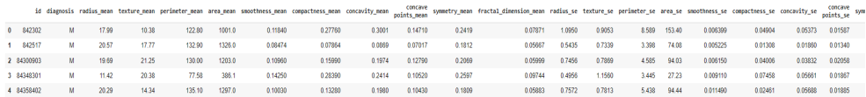

*Glimpses of Brest cancer dataset*

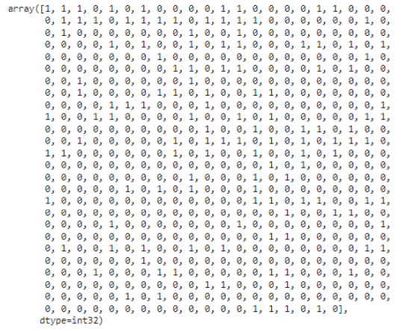 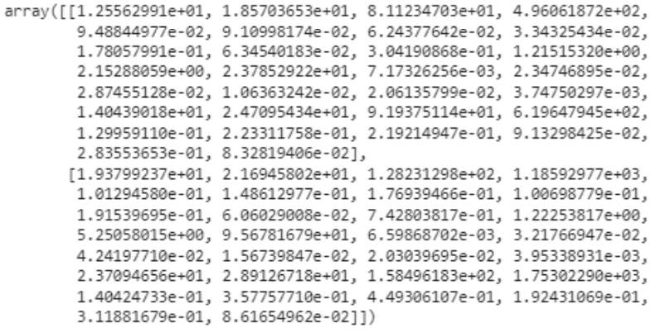

*K means labels cluster centers*

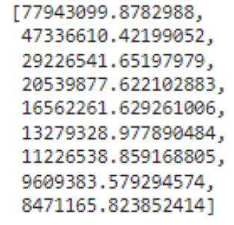 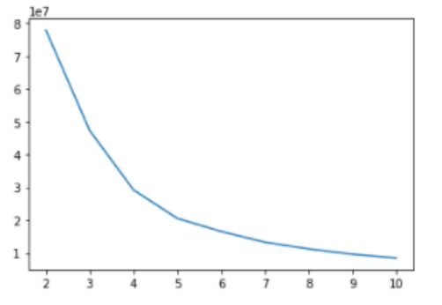

*WCSS sum of squared distance graph plot (elbow)*

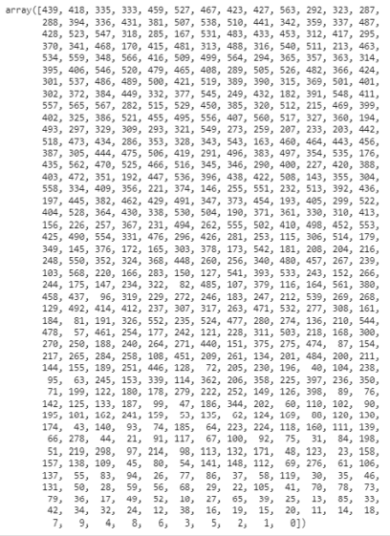

*Hierachical cluster label*

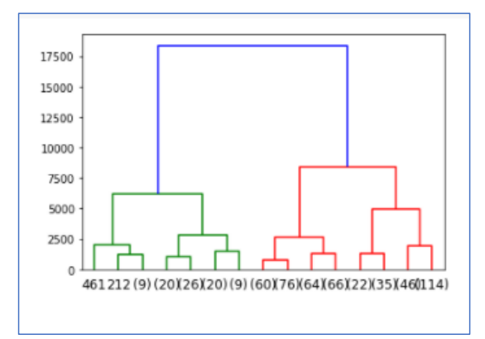

*Dendrogram*

**PRACTICAL-8**

**AIM:**

Implement following using Tensorflow:

Constants, Variables, Placeholder, and operations, creating Graph and executing graph.

**CODE:**

import tensorflow as tf

print("TensorFlow version:", tf._version_)

mnist = tf.keras.datasets.mnist

(x_train, y_train), (x_test, y_test) = mnist.load_data()

x_train, x_test = x_train / 255.0, x_test / 255.0

model = tf.keras.models.Sequential([

tf.keras.layers.Flatten(input_shape=(28, 28)),

tf.keras.layers.Dense(128, activation='relu'),

tf.keras.layers.Dropout(0.2),

tf.keras.layers.Dense(10)

])

loss_fn = tf.keras.losses.SparseCategoricalCrossentropy(from_logits=True)

model.compile(optimizer='adam',

loss=loss_fn,

metrics=['accuracy'])

model.fit(x_train, y_train, epochs=5)

model.evaluate(x_test, y_test, verbose=2)

**OUTPUT:**

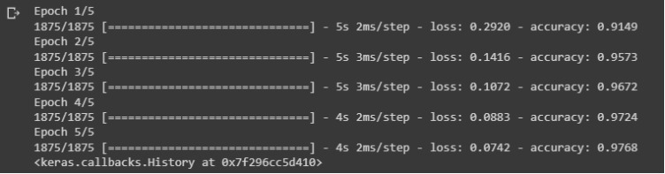



**PRACTICAL-9**

**AIM:**

Implement the Multi-Layer Perceptron from scratch with at least 3 layers for a classification or a regression problem of your

choice, implement Backpropogation and observe Underfitting, Overfitting and Regularization.

**CODE:**

from google.colab import drive

drive.mount('/gdrive')

%cd /gdrive

%cd MyDrive/Colab\ Notebooks

%ls

%cd

%cd /gdrive/MyDrive/Datasets

%ls

import pandas as pd

df = pd.read_csv('/content/wineQT.csv')

df.head(5)

df.drop('Id', axis=1, inplace=True)

df.head()

from sklearn.neural_network import MLPClassifier

y = df['quality']

y.head()

X = df.drop('quality', axis=1, inplace=False)

X.head()

X.describe()

model = MLPClassifier(solver='sgd', hidden_layer_sizes=(16, 8), random_state=1, learning_rate_init=0.005, learning_rate='adaptive', verbose=True, validation_fraction=0.1, early_stopping=True)

model.fit(X,y)

model2 = MLPClassifier(solver='sgd', hidden_layer_sizes=(24, 8), random_state=1, learning_rate_init=0.005, learning_rate='adaptive', verbose=True, validation_fraction=0.1, early_stopping=True)

model2.fit(X,y)

import matplotlib.pyplot as plt

plt.plot(model.loss_curve_)

plt.plot(model2.loss_curve_)

model3 = MLPClassifier(solver='sgd', hidden_layer_sizes=(16, 12), random_state=1, learning_rate_init=0.001, learning_rate='invscaling', verbose=True, validation_fraction=0.1, early_stopping=True)

model3.fit(X,y)

plt.plot(model3.loss_curve_)

model3.score(X,y)

import pickle

filename = 'finalized_sklearn_classification_model.sav'

pickle.dump(model3, open(filename, 'wb'))

loaded_model = pickle.load(open(filename, 'rb'))

loaded_model.score(X,y)

**OUTPUT:**

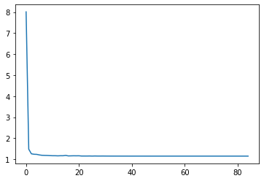  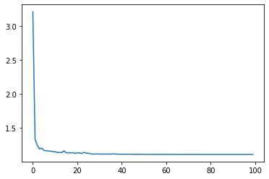

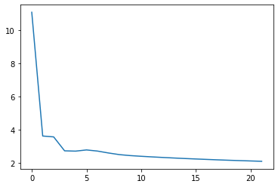

*The loss curves*

**PRACTICAL-10**

**AIM:**

Implement a Convolutional Neural Network (CNN) using Keras library for a face classification problem. Create dataset of faces of

your 5 friends. Also use data augmentation technique to increase dataset.

**CODE:**

import tensorflow as tf

from tensorflow.keras import datasets, layers, models

import matplotlib.pyplot as plt

(train_images, train_labels), (test_images, test_labels) = datasets.cifar10.load_data()

# Normalize pixel values to be between 0 and 1

train_images, test_images = train_images / 255.0, test_images / 255.0

class_names = ['airplane', 'automobile', 'bird', 'cat', 'deer',

'dog', 'frog', 'horse', 'ship', 'truck']

plt.figure(figsize=(10,10))

for i in range(25):

plt.subplot(5,5,i+1)

plt.xticks([])

plt.yticks([])

plt.grid(False)

plt.imshow(train_images[i])

# The CIFAR labels happen to be arrays,

# which is why you need the extra index

plt.xlabel(class_names[train_labels[i][0]])

plt.show()

model = models.Sequential()

model.add(layers.Conv2D(32, (3, 3), activation='relu', input_shape=(32, 32, 3)))

model.add(layers.MaxPooling2D((2, 2)))

model.add(layers.Conv2D(64, (3, 3), activation='relu'))

model.add(layers.MaxPooling2D((2, 2)))

model.add(layers.Conv2D(64, (3, 3), activation='relu'))

model.summary()

model.add(layers.Flatten())

model.add(layers.Dense(64, activation='relu'))

model.add(layers.Dense(10))

model.summary()

model.compile(optimizer='adam',

loss=tf.keras.losses.SparseCategoricalCrossentropy(from_logits=True),

metrics=['accuracy'])

history = model.fit(train_images, train_labels, epochs=10,

validation_data=(test_images, test_labels))

plt.plot(history.history['accuracy'], label='accuracy')

plt.plot(history.history['val_accuracy'], label = 'val_accuracy')

plt.xlabel('Epoch')

plt.ylabel('Accuracy')

plt.ylim([0.5, 1])

plt.legend(loc='lower right')

test_loss, test_acc = model.evaluate(test_images, test_labels, verbose=2)

print(test_acc)

**OUTPUT:**

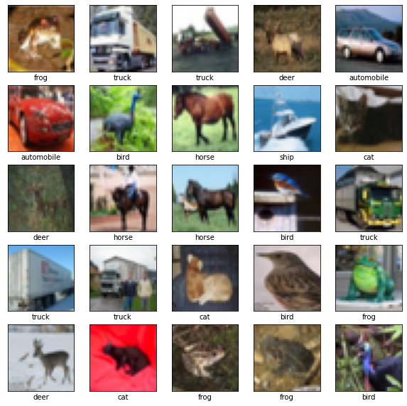

Glimpses of the images used

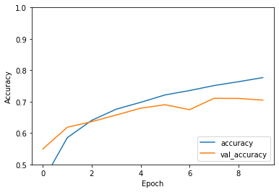

**PRACTICAL-11**

**AIM:**

Train a Reinforcement Learning Agent for the Multi-Armed Bandit Problem and visualize the results using matplotlib or seaborn

libraries in Python. Consider at least 15 arms (n=15).

**CODE:**

!pip install tf-agents

import abc

import numpy as np

import tensorflow as tf

from tf_agents.agents import tf_agent

from tf_agents.drivers import driver

from tf_agents.environments import py_environment

from tf_agents.environments import tf_environment

from tf_agents.environments import tf_py_environment

from tf_agents.policies import tf_policy

from tf_agents.specs import array_spec

from tf_agents.specs import tensor_spec

from tf_agents.trajectories import time_step as ts

from tf_agents.trajectories import trajectory

from tf_agents.trajectories import policy_step

nest = tf.nest

class BanditPyEnvironment(py_environment.PyEnvironment):

def _init_(self, observation_spec, action_spec):

self._observation_spec = observation_spec

self._action_spec = action_spec

super(BanditPyEnvironment, self)._init_()

# Helper functions.

def action_spec(self):

return self._action_spec

def observation_spec(self):

return self._observation_spec

def _empty_observation(self):

return tf.nest.map_structure(lambda x: np.zeros(x.shape, x.dtype),

self.observation_spec())

# These two functions below should not be overridden by subclasses.

def _reset(self):

"""Returns a time step containing an observation."""

return ts.restart(self._observe(), batch_size=self.batch_size)

def _step(self, action):

"""Returns a time step containing the reward for the action taken."""

reward = self._apply_action(action)

return ts.termination(self._observe(), reward)

# These two functions below are to be implemented in subclasses.

@abc.abstractmethod

def _observe(self):

"""Returns an observation."""

@abc.abstractmethod

def _apply_action(self, action):

"""Applies `action` to the Environment and returns the corresponding reward.

"""

class SimplePyEnvironment(BanditPyEnvironment):

def _init_(self):

action_spec = array_spec.BoundedArraySpec(

shape=(), dtype=np.int32, minimum=0, maximum=2, name='action')

observation_spec = array_spec.BoundedArraySpec(

shape=(1,), dtype=np.int32, minimum=-2, maximum=2, name='observation')

super(SimplePyEnvironment, self)._init_(observation_spec, action_spec)

def _observe(self):

self._observation = np.random.randint(-2, 3, (1,), dtype='int32')

return self._observation

def _apply_action(self, action):

return action * self._observation

environment = SimplePyEnvironment()

observation = environment.reset().observation

print("observation: %d" % observation)

action = 2 #@param

print("action: %d" % action)

reward = environment.step(action).reward

print("reward: %f" % reward)

tf_environment = tf_py_environment.TFPyEnvironment(environment)

class SignPolicy(tf_policy.TFPolicy):

def _init_(self):

observation_spec = tensor_spec.BoundedTensorSpec(

shape=(1,), dtype=tf.int32, minimum=-2, maximum=2)

time_step_spec = ts.time_step_spec(observation_spec)

action_spec = tensor_spec.BoundedTensorSpec(

shape=(), dtype=tf.int32, minimum=0, maximum=2)

super(SignPolicy, self)._init_(time_step_spec=time_step_spec,

action_spec=action_spec)

def _distribution(self, time_step):

pass

def _variables(self):

return ()

def _action(self, time_step, policy_state, seed):

observation_sign = tf.cast(tf.sign(time_step.observation[0]), dtype=tf.int32)

action = observation_sign + 1

return policy_step.PolicyStep(action, policy_state)

sign_policy = SignPolicy()

current_time_step = tf_environment.reset()

print('Observation:')

print (current_time_step.observation)

action = sign_policy.action(current_time_step).action

print('Action:')

print (action)

reward = tf_environment.step(action).reward

print('Reward:')

print(reward)

step = tf_environment.reset()

action = 1

next_step = tf_environment.step(action)

reward = next_step.reward

next_observation = next_step.observation

print("Reward: ")

print(reward)

print("Next observation:")

print(next_observation)

class TwoWayPyEnvironment(BanditPyEnvironment):

def _init_(self):

action_spec = array_spec.BoundedArraySpec(

shape=(), dtype=np.int32, minimum=0, maximum=2, name='action')

observation_spec = array_spec.BoundedArraySpec(

shape=(1,), dtype=np.int32, minimum=-2, maximum=2, name='observation')

# Flipping the sign with probability 1/2.

self._reward_sign = 2 * np.random.randint(2) - 1

print("reward sign:")

print(self._reward_sign)

super(TwoWayPyEnvironment, self)._init_(observation_spec, action_spec)

def _observe(self):

self._observation = np.random.randint(-2, 3, (1,), dtype='int32')

return self._observation

def _apply_action(self, action):

return self._reward_sign * action * self._observation[0]

two_way_tf_environment = tf_py_environment.TFPyEnvironment(TwoWayPyEnvironment())

class TwoWaySignPolicy(tf_policy.TFPolicy):

def _init_(self, situation):

observation_spec = tensor_spec.BoundedTensorSpec(

shape=(1,), dtype=tf.int32, minimum=-2, maximum=2)

action_spec = tensor_spec.BoundedTensorSpec(

shape=(), dtype=tf.int32, minimum=0, maximum=2)

time_step_spec = ts.time_step_spec(observation_spec)

self._situation = situation

super(TwoWaySignPolicy, self)._init_(time_step_spec=time_step_spec,

action_spec=action_spec)

def _distribution(self, time_step):

pass

def _variables(self):

return [self._situation]

def _action(self, time_step, policy_state, seed):

sign = tf.cast(tf.sign(time_step.observation[0, 0]), dtype=tf.int32)

def case_unknown_fn():

# Choose 1 so that we get information on the sign.

return tf.constant(1, shape=(1,))

# Choose 0 or 2, depending on the situation and the sign of the observation.

def case_normal_fn():

return tf.constant(sign + 1, shape=(1,))

def case_flipped_fn():

return tf.constant(1 - sign, shape=(1,))

cases = [(tf.equal(self._situation, 0), case_unknown_fn),

(tf.equal(self._situation, 1), case_normal_fn),

(tf.equal(self._situation, 2), case_flipped_fn)]

action = tf.case(cases, exclusive=True)

return policy_step.PolicyStep(action, policy_state)

class SignAgent(tf_agent.TFAgent):

def _init_(self):

self._situation = tf.Variable(0, dtype=tf.int32)

policy = TwoWaySignPolicy(self._situation)

time_step_spec = policy.time_step_spec

action_spec = policy.action_spec

super(SignAgent, self)._init_(time_step_spec=time_step_spec,

action_spec=action_spec,

policy=policy,

collect_policy=policy,

train_sequence_length=None)

def _initialize(self):

return tf.compat.v1.variables_initializer(self.variables)

def _train(self, experience, weights=None):

observation = experience.observation

action = experience.action

reward = experience.reward

# We only need to change the value of the situation variable if it is

# unknown (0) right now, and we can infer the situation only if the

# observation is not 0.

needs_action = tf.logical_and(tf.equal(self._situation, 0),

tf.not_equal(reward, 0))

def new_situation_fn():

"""This returns either 1 or 2, depending on the signs."""

return (3 - tf.sign(tf.cast(observation[0, 0, 0], dtype=tf.int32) *

tf.cast(action[0, 0], dtype=tf.int32) *

tf.cast(reward[0, 0], dtype=tf.int32))) / 2

new_situation = tf.cond(needs_action,

new_situation_fn,

lambda: self._situation)

new_situation = tf.cast(new_situation, tf.int32)

tf.compat.v1.assign(self._situation, new_situation)

return tf_agent.LossInfo((), ())

sign_agent = SignAgent()

# We need to add another dimension here because the agent expects the

# trajectory of shape [batch_size, time, ...], but in this tutorial we assume

# that both batch size and time are 1. Hence all the expand_dims.

def trajectory_for_bandit(initial_step, action_step, final_step):

return trajectory.Trajectory(observation=tf.expand_dims(initial_step.observation, 0),

action=tf.expand_dims(action_step.action, 0),

policy_info=action_step.info,

reward=tf.expand_dims(final_step.reward, 0),

discount=tf.expand_dims(final_step.discount, 0),

step_type=tf.expand_dims(initial_step.step_type, 0),

next_step_type=tf.expand_dims(final_step.step_type, 0))

step = two_way_tf_environment.reset()

for _ in range(10):

action_step = sign_agent.collect_policy.action(step)

next_step = two_way_tf_environment.step(action_step.action)

experience = trajectory_for_bandit(step, action_step, next_step)

print(experience)

sign_agent.train(experience)

step = next_step

# Imports for example.

from tf_agents.bandits.agents import lin_ucb_agent

from tf_agents.bandits.environments import stationary_stochastic_py_environment as sspe

from tf_agents.bandits.metrics import tf_metrics

from tf_agents.drivers import dynamic_step_driver

from tf_agents.replay_buffers import tf_uniform_replay_buffer

import matplotlib.pyplot as plt

batch_size = 2 # @param

arm0_param = [-3, 0, 1, -2] # @param

arm1_param = [1, -2, 3, 0] # @param

arm2_param = [0, 0, 1, 1] # @param

def context_sampling_fn(batch_size):

"""Contexts from [-10, 10]^4."""

def _context_sampling_fn():

return np.random.randint(-10, 10, [batch_size, 4]).astype(np.float32)

return _context_sampling_fn

class LinearNormalReward(object):

"""A class that acts as linear reward function when called."""

def _init_(self, theta, sigma):

self.theta = theta

self.sigma = sigma

def _call_(self, x):

mu = np.dot(x, self.theta)

return np.random.normal(mu, self.sigma)

arm0_reward_fn = LinearNormalReward(arm0_param, 1)

arm1_reward_fn = LinearNormalReward(arm1_param, 1)

arm2_reward_fn = LinearNormalReward(arm2_param, 1)

environment = tf_py_environment.TFPyEnvironment(

sspe.StationaryStochasticPyEnvironment(

context_sampling_fn(batch_size),

[arm0_reward_fn, arm1_reward_fn, arm2_reward_fn],

batch_size=batch_size))

observation_spec = tensor_spec.TensorSpec([4], tf.float32)

time_step_spec = ts.time_step_spec(observation_spec)

action_spec = tensor_spec.BoundedTensorSpec(

dtype=tf.int32, shape=(), minimum=0, maximum=2)

agent = lin_ucb_agent.LinearUCBAgent(time_step_spec=time_step_spec,

action_spec=action_spec)

def compute_optimal_reward(observation):

expected_reward_for_arms = [

tf.linalg.matvec(observation, tf.cast(arm0_param, dtype=tf.float32)),

tf.linalg.matvec(observation, tf.cast(arm1_param, dtype=tf.float32)),

tf.linalg.matvec(observation, tf.cast(arm2_param, dtype=tf.float32))]

optimal_action_reward = tf.reduce_max(expected_reward_for_arms, axis=0)

return optimal_action_reward

regret_metric = tf_metrics.RegretMetric(compute_optimal_reward)

num_iterations = 90 # @param

steps_per_loop = 1 # @param

replay_buffer = tf_uniform_replay_buffer.TFUniformReplayBuffer(

data_spec=agent.policy.trajectory_spec,

batch_size=batch_size,

max_length=steps_per_loop)

observers = [replay_buffer.add_batch, regret_metric]

driver = dynamic_step_driver.DynamicStepDriver(

env=environment,

policy=agent.collect_policy,

num_steps=steps_per_loop * batch_size,

observers=observers)

regret_values = []

for _ in range(num_iterations):

driver.run()

loss_info = agent.train(replay_buffer.gather_all())

replay_buffer.clear()

regret_values.append(regret_metric.result())

plt.plot(regret_values)

plt.ylabel('Average Regret')

plt.xlabel('Number of Iterations')

**OUTPUT:**

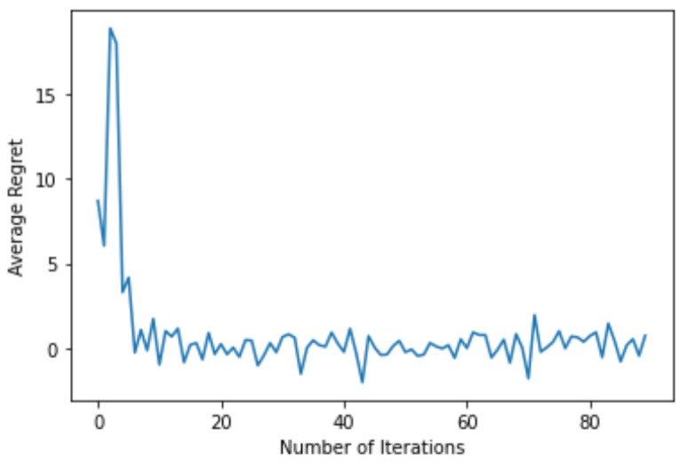

**PRACTICAL-12**

**AIM:**

Implement a Deep Learning Algorithm/Method to Predict stock prices based on past price variation.

**CODE:**

pip install yahoo-fin

import tensorflow as tf

from tensorflow.keras.models import Sequential

from tensorflow.keras.layers import LSTM, Dense, Dropout, Bidirectional

from tensorflow.keras.callbacks import ModelCheckpoint, TensorBoard

from sklearn import preprocessing

from sklearn.model_selection import train_test_split

from yahoo_fin import stock_info as si

from collections import deque

import os

import numpy as np

import pandas as pd

import random

# set seed, so we can get the same results after rerunning several times

np.random.seed(314)

tf.random.set_seed(314)

random.seed(314)

import os

import time

from tensorflow.keras.layers import LSTM

# Window size or the sequence length

N_STEPS = 50

# Lookup step, 1 is the next day

LOOKUP_STEP = 15

# whether to scale feature columns & output price as well

SCALE = True

scale_str = f"sc-{int(SCALE)}"

# whether to shuffle the dataset

SHUFFLE = True

shuffle_str = f"sh-{int(SHUFFLE)}"

# whether to split the training/testing set by date

SPLIT_BY_DATE = False

split_by_date_str = f"sbd-{int(SPLIT_BY_DATE)}"

# test ratio size, 0.2 is 20%

TEST_SIZE = 0.2

# features to use

FEATURE_COLUMNS = ["adjclose", "volume", "open", "high", "low"]

# date now

date_now = time.strftime("%Y-%m-%d")

### model parameters

N_LAYERS = 2

# LSTM cell

CELL = LSTM

# 256 LSTM neurons

UNITS = 256

# 40% dropout

DROPOUT = 0.4

# whether to use bidirectional RNNs

BIDIRECTIONAL = False

### training parameters

# mean absolute error loss

# LOSS = "mae"

# huber loss

LOSS = "huber_loss"

OPTIMIZER = "adam"

BATCH_SIZE = 64

EPOCHS = 500

# Amazon stock market

ticker = "AMZN"

ticker_data_filename = os.path.join("data", f"{ticker}_{date_now}.csv")

# model name to save, making it as unique as possible based on parameters

model_name = f"{date_now}_{ticker}-{shuffle_str}-{scale_str}-{split_by_date_str}-\

{LOSS}-{OPTIMIZER}-{CELL.__name__}-seq-{N_STEPS}-step-{LOOKUP_STEP}-layers-{N_LAYERS}-units-{UNITS}"

if BIDIRECTIONAL:

model_name += "-b"

def shuffle_in_unison(a, b):

# shuffle two arrays in the same way

state = np.random.get_state()

np.random.shuffle(a)

np.random.set_state(state)

np.random.shuffle(b)

def load_data(ticker, n_steps=50, scale=True, shuffle=True, lookup_step=1, split_by_date=True,

test_size=0.2, feature_columns=['adjclose', 'volume', 'open', 'high', 'low']):

# see if ticker is already a loaded stock from yahoo finance

if isinstance(ticker, str):

# load it from yahoo_fin library

df = si.get_data(ticker)

elif isinstance(ticker, pd.DataFrame):

# already loaded, use it directly

df = ticker

else:

raise TypeError("ticker can be either a str or a `pd.DataFrame` instances")

# this will contain all the elements we want to return from this function

result = {}

# we will also return the original dataframe itself

result['df'] = df.copy()

# make sure that the passed feature_columns exist in the dataframe

for col in feature_columns:

assert col in df.columns, f"'{col}' does not exist in the dataframe."

# add date as a column

if "date" not in df.columns:

df["date"] = df.index

if scale:

column_scaler = {}

# scale the data (prices) from 0 to 1

for column in feature_columns:

scaler = preprocessing.MinMaxScaler()

df[column] = scaler.fit_transform(np.expand_dims(df[column].values, axis=1))

column_scaler[column] = scaler

# add the MinMaxScaler instances to the result returned

result["column_scaler"] = column_scaler

# add the target column (label) by shifting by `lookup_step`

df['future'] = df['adjclose'].shift(-lookup_step)

# last `lookup_step` columns contains NaN in future column

# get them before droping NaNs

last_sequence = np.array(df[feature_columns].tail(lookup_step))

# drop NaNs

df.dropna(inplace=True)

sequence_data = []

sequences = deque(maxlen=n_steps)

for entry, target in zip(df[feature_columns + ["date"]].values, df['future'].values):

sequences.append(entry)

if len(sequences) == n_steps:

sequence_data.append([np.array(sequences), target])

# get the last sequence by appending the last `n_step` sequence with `lookup_step` sequence

# for instance, if n_steps=50 and lookup_step=10, last_sequence should be of 60 (that is 50+10) length

# this last_sequence will be used to predict future stock prices that are not available in the dataset

last_sequence = list([s[:len(feature_columns)] for s in sequences]) + list(last_sequence)

last_sequence = np.array(last_sequence).astype(np.float32)

# add to result

result['last_sequence'] = last_sequence

# construct the X's and y's

X, y = [], []

for seq, target in sequence_data:

X.append(seq)

y.append(target)

# convert to numpy arrays

X = np.array(X)

y = np.array(y)

if split_by_date:

# split the dataset into training & testing sets by date (not randomly splitting)

train_samples = int((1 - test_size) * len(X))

result["X_train"] = X[:train_samples]

result["y_train"] = y[:train_samples]

result["X_test"] = X[train_samples:]

result["y_test"] = y[train_samples:]

if shuffle:

# shuffle the datasets for training (if shuffle parameter is set)

shuffle_in_unison(result["X_train"], result["y_train"])

shuffle_in_unison(result["X_test"], result["y_test"])

else:

# split the dataset randomly

result["X_train"], result["X_test"], result["y_train"], result["y_test"] = train_test_split(X, y, test_size=test_size, shuffle=shuffle)

# get the list of test set dates

dates = result["X_test"][:, -1, -1]

# retrieve test features from the original dataframe

result["test_df"] = result["df"].loc[dates]

# remove duplicated dates in the testing dataframe

result["test_df"] = result["test_df"][~result["test_df"].index.duplicated(keep='first')]

# remove dates from the training/testing sets & convert to float32

result["X_train"] = result["X_train"][:, :, :len(feature_columns)].astype(np.float32)

result["X_test"] = result["X_test"][:, :, :len(feature_columns)].astype(np.float32)

return result

def create_model(sequence_length, n_features, units=256, cell=LSTM, n_layers=2, dropout=0.3,

loss="mean_absolute_error", optimizer="rmsprop", bidirectional=False):

model = Sequential()

for i in range(n_layers):

if i == 0:

# first layer

if bidirectional:

model.add(Bidirectional(cell(units, return_sequences=True), batch_input_shape=(None, sequence_length, n_features)))

else:

model.add(cell(units, return_sequences=True, batch_input_shape=(None, sequence_length, n_features)))

elif i == n_layers - 1:

# last layer

if bidirectional:

model.add(Bidirectional(cell(units, return_sequences=False)))

else:

model.add(cell(units, return_sequences=False))

else:

# hidden layers

if bidirectional:

model.add(Bidirectional(cell(units, return_sequences=True)))

else:

model.add(cell(units, return_sequences=True))

# add dropout after each layer

model.add(Dropout(dropout))

model.add(Dense(1, activation="linear"))

model.compile(loss=loss, metrics=["mean_absolute_error"], optimizer=optimizer)

return model

# create these folders if they does not exist

if not os.path.isdir("results"):

os.mkdir("results")

if not os.path.isdir("logs"):

os.mkdir("logs")

if not os.path.isdir("data"):

os.mkdir("data")

# load the data

data = load_data(ticker, N_STEPS, scale=SCALE, split_by_date=SPLIT_BY_DATE,

shuffle=SHUFFLE, lookup_step=LOOKUP_STEP, test_size=TEST_SIZE,

feature_columns=FEATURE_COLUMNS)

# save the dataframe

data["df"].to_csv(ticker_data_filename)

# construct the model

model = create_model(N_STEPS, len(FEATURE_COLUMNS), loss=LOSS, units=UNITS, cell=CELL, n_layers=N_LAYERS,

dropout=DROPOUT, optimizer=OPTIMIZER, bidirectional=BIDIRECTIONAL)

# some tensorflow callbacks

checkpointer = ModelCheckpoint(os.path.join("results", model_name + ".h5"), save_weights_only=True, save_best_only=True, verbose=1)

tensorboard = TensorBoard(log_dir=os.path.join("logs", model_name))

# train the model and save the weights whenever we see

# a new optimal model using ModelCheckpoint

history = model.fit(data["X_train"], data["y_train"],

batch_size=BATCH_SIZE,

epochs=EPOCHS,

validation_data=(data["X_test"], data["y_test"]),

callbacks=[checkpointer, tensorboard],

verbose=1)

import matplotlib.pyplot as plt

def plot_graph(test_df):

"""

This function plots true close price along with predicted close price

with blue and red colors respectively

"""

plt.plot(test_df[f'true_adjclose_{LOOKUP_STEP}'], c='b')

plt.plot(test_df[f'adjclose_{LOOKUP_STEP}'], c='r')

plt.xlabel("Days")

plt.ylabel("Price")

plt.legend(["Actual Price", "Predicted Price"])

plt.show()

def get_final_df(model, data):

"""

This function takes the `model` and `data` dict to

construct a final dataframe that includes the features along

with true and predicted prices of the testing dataset

"""

# if predicted future price is higher than the current,

# then calculate the true future price minus the current price, to get the buy profit

buy_profit = lambda current, pred_future, true_future: true_future - current if pred_future > current else 0

# if the predicted future price is lower than the current price,

# then subtract the true future price from the current price

sell_profit = lambda current, pred_future, true_future: current - true_future if pred_future < current else 0

X_test = data["X_test"]

y_test = data["y_test"]

# perform prediction and get prices

y_pred = model.predict(X_test)

if SCALE:

y_test = np.squeeze(data["column_scaler"]["adjclose"].inverse_transform(np.expand_dims(y_test, axis=0)))

y_pred = np.squeeze(data["column_scaler"]["adjclose"].inverse_transform(y_pred))

test_df = data["test_df"]

# add predicted future prices to the dataframe

test_df[f"adjclose_{LOOKUP_STEP}"] = y_pred

# add true future prices to the dataframe

test_df[f"true_adjclose_{LOOKUP_STEP}"] = y_test

# sort the dataframe by date

test_df.sort_index(inplace=True)

final_df = test_df

# add the buy profit column

final_df["buy_profit"] = list(map(buy_profit,

final_df["adjclose"],

final_df[f"adjclose_{LOOKUP_STEP}"],

final_df[f"true_adjclose_{LOOKUP_STEP}"])

# since we don't have profit for last sequence, add 0's

)

# add the sell profit column

final_df["sell_profit"] = list(map(sell_profit,

final_df["adjclose"],

final_df[f"adjclose_{LOOKUP_STEP}"],

final_df[f"true_adjclose_{LOOKUP_STEP}"])

# since we don't have profit for last sequence, add 0's

)

return final_df

def predict(model, data):

# retrieve the last sequence from data

last_sequence = data["last_sequence"][-N_STEPS:]

# expand dimension

last_sequence = np.expand_dims(last_sequence, axis=0)

# get the prediction (scaled from 0 to 1)

prediction = model.predict(last_sequence)

# get the price (by inverting the scaling)

if SCALE:

predicted_price = data["column_scaler"]["adjclose"].inverse_transform(prediction)[0][0]

else:

predicted_price = prediction[0][0]

return predicted_price

# load optimal model weights from results folder

model_path = os.path.join("results", model_name) + ".h5"

model.load_weights(model_path)

# evaluate the model

loss, mae = model.evaluate(data["X_test"], data["y_test"], verbose=0)

# calculate the mean absolute error (inverse scaling)

if SCALE:

mean_absolute_error = data["column_scaler"]["adjclose"].inverse_transform([[mae]])[0][0]

else:

mean_absolute_error = mae

# get the final dataframe for the testing set

final_df = get_final_df(model, data)

# predict the future price

future_price = predict(model, data)

# we calculate the accuracy by counting the number of positive profits

accuracy_score = (len(final_df[final_df['sell_profit'] > 0]) + len(final_df[final_df['buy_profit'] > 0])) / len(final_df)

# calculating total buy & sell profit

total_buy_profit = final_df["buy_profit"].sum()

total_sell_profit = final_df["sell_profit"].sum()

# total profit by adding sell & buy together

total_profit = total_buy_profit + total_sell_profit

# dividing total profit by number of testing samples (number of trades)

profit_per_trade = total_profit / len(final_df)

# printing metrics

print(f"Future price after {LOOKUP_STEP} days is {future_price:.2f}$")

print(f"{LOSS} loss:", loss)

print("Mean Absolute Error:", mean_absolute_error)

print("Accuracy score:", accuracy_score)

print("Total buy profit:", total_buy_profit)

print("Total sell profit:", total_sell_profit)

print("Total profit:", total_profit)

print("Profit per trade:", profit_per_trade)

# plot true/pred prices graph

plot_graph(final_df)

final_df.head(20)

final_df.tail(20)

# save the final dataframe to csv-results folder

csv_results_folder = "csv-results"

if not os.path.isdir(csv_results_folder):

os.mkdir(csv_results_folder)

csv_filename = os.path.join(csv_results_folder, model_name + ".csv")

final_df.to_csv(csv_filename)

**OUTPUT:**

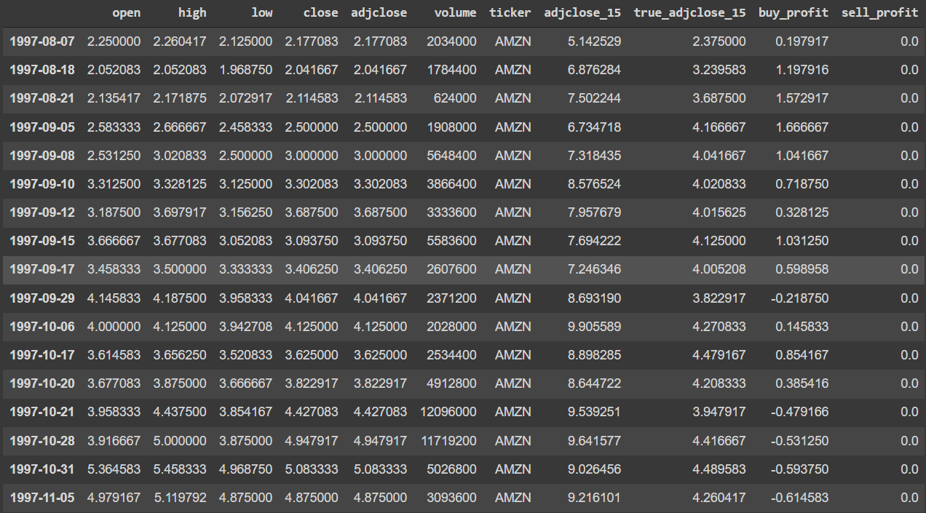

Output of Head()

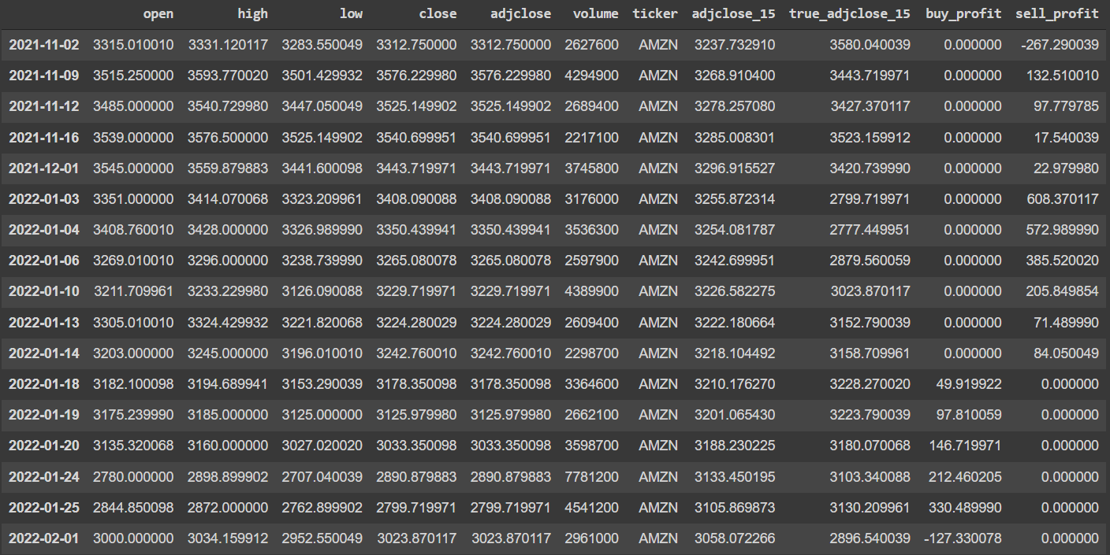

Output of Tail()

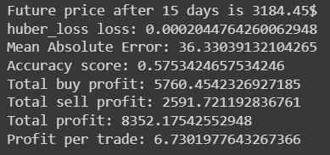 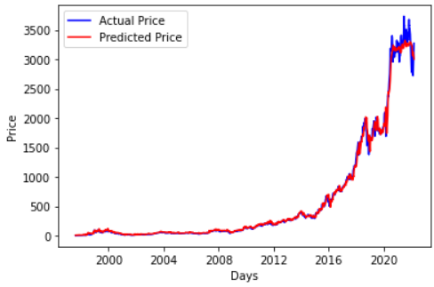

Metrics Actual vs predicted price